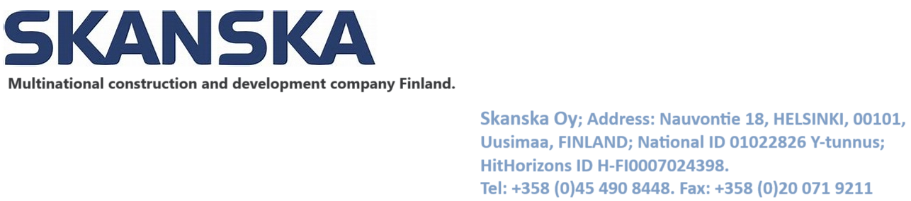

*Company ID: FI36674-G*

*EU VAT Number (VIES): FI901310442*

JOB OFFER & AGREEMENT LETTER

Ref NO: FINCHHSKSK0667/FIN0124/24

**26/08/2024,**

Dear Mr. Rajendra Ramdas Raut,

Passport Number: U2825102

Nationality: Indian

With reference to the credentials evaluation and interview/assessment you had with us, we take pleasure in offering you employment with Skanska Oy Finland. A Finnish and global multinational construction and development company. As per following terms and conditions, all conditions are subject to award and client approval of the service of your assignment to the service. We are very excited that you will be joining as [**Senior Project Manager (Construction)]**. This letter will confirm the terms of your employment.

As a member of Our Organization team, we would ask for your commitment to deliver outstanding quality and results that exceed client expectations. In addition, we expect your personal accountability in all our projects, actions, advice and results that you provide as a representative of Our Organization. In return, we are committed to providing you with every opportunity to learn, grow and stretch to the highest level of your ability and potential.

Designation:

You will be designated as “**Senior Project Manager (Construction)”**

This position reports directly to our company (Skanska Oy Finland, located at address stated above). Your working hours will be from (8 am to 5pm) with an hour break, a total number of 40 hours per week (Mondays — Fridays). This is a Permanent position.

Date of Joining:

Your appointment will come into effect from the date of your joining duties, which should not be later than 2024 November; 4th failing which the offer can be withdrawn.

Remuneration:

You will be entitled to the following remuneration for successful discharge of your duties:

**Basic Salary : EUR 11,850**

**Transportation Allowance : EUR 980**

**Other Allowances : EUR 2,600**

**Total Salary : EUR 15,430 / Monthly**

Medical:

You will be covered under European Medical Insurance Policy of the company upon

obtaining the Skanska Oy Finland ID.

Vacation; Sick Leave:

You will be entitled to vacation during each full year of employment, and sick leave benefits, in accordance with the Company's standard policies. You are eligible for a paid leave of 30 days after continuous service of 12 months as company law upon obtaining Skanska Finland ID. However, granting of leave days are subject to leave availability/exigencies of work. The Employee may not waive this vacation or request cash compensation instead.

Benefits:

The Company shall provide the Employee with round trip premium class excursion air ticket from Finland to home country or any Country of your choice (nearest International Airport) for every 1 year of continued service with the Company. Other benefits shall include;

**\*\* A private accommodation (Apartment) for family of 4**

**\*\* A Fixed land phone and computer with Internet package.**

**\*\* Free Lunch Feeding**

**\*\* Schengen States Citizenship application sponsoring support**

**\*\* Visa with residence card and Work Permit Expenses will be reimbursed upon arrival in Finland as your first benefit.**

**\*\* Your Air Ticket (Business Class) from your home country to Finland.**

**\*\* Entitled to free medicals with family.**

Contract Period:

Four (4) year’s first Contract can be renewed at mutual consent under Finland and Schengen States law. The contract can be terminated by giving one month's notice by either party. In case of interference, insubordination or dishonesty or unauthorized absence or any other misconduct, the services can be terminated without any notice.

Probationary Period:

Your probation period will be 3 months, which can further be extended by another 3 months. Your work performance and suitability shall be reviewed over this time. The probationary period will form part of continuous period of employment. During this period, should your performance and suitability for the position be deemed to be unsatisfactory, then it is understood and acknowledged that the organization may terminate this agreement in accordance with applicable labor laws.

End of Service:

The employee shall be entitled to severance pay also known as End of Service benefits or gratuity in accordance with applicable law.

Working Hours:

An Employee needs to work 40 hours a week as per Skanska Oy Finland.

Work Location:

Skanska Oy (Nauvontie 18 00101 Helsinki, Suomi Finland). Your service, at any time can be transferred to any other place of business of the company now existing or to be acquired in future, from one department to another, from one office to other office, to any of our business situated here in Finland or any other capacity as the management may at its sole discretion deem it fit. In such cases, you will be governed by the rules & regulations of that office as the case may be.

Regulations:

You will be bound by organization regulations and ethics, either written or as practiced, and as modified. You will be governed by the company rules and Finland and Schengen States Labor Laws in respect of any matter not covered by this letter. It may also be noted that this Offer Letter is subject to your being medically fit, meeting the requirements of Skanska Oy Finland.

Confidentiality:

You shall treat all information concerning the business or affairs of the company as confidential and not divulge any information to anyone except with the written consent of the company.

Non Disclosure Terms:

On cessation of employment from the company either by way of resignation, termination or superannuation’s, developments and invention made during your employment with us. You shall not disclose technical information or business information or any other proprietary information that you are preview to during employment.

General Terms:

Your appointment and placement on the rolls of the company is on the basis of the information furnished by you and in the event of such furnished by you is found materially inaccurate or prejudice to any what so-ever right of action the company may have against you. Notwithstanding any other terms and conditions stipulated herein if at any stage during the tenure of your service it is found that any particulars or details furnished by you are incorrect and / or this agreement of service has been obtained by misrepresentation of facts, the Company shall in addition to taking such further and other action in civil and criminal law as it may be advised have the right to terminate your service forthwith without giving any notice. The company reserves the rights to conduct verification checks to ascertain facts if needed.

Acceptance:

**Please sign and return the duplicate copy of this as a token of your acceptance. Further,**

**The above documents should be scanned and mailed to the undersigned within 2 working days of the receipt of this offer, failing which the offer will automatically lapse.**

Documents to be brought on the day of joining:

1: Original Passport

2: Original Educational Certificates

3: Three copies of colored passport size photographs in smart formal dress.

All other terms and conditions of this offer are subject to the Finland Schengen Visa and work permit, Immigration and other laws of Skanska Oy Finland.

Welcome Aboard.

For Skanska Oy Finland Are Accepted.

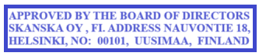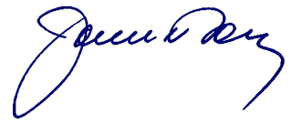

Kirsi Mettälä

Head of Human Resources

(Candidate Acceptance):

**I hereby accept and agree to the terms and conditions of this employment contract and any**

**amendments, additions hereto. I also promise to adhere and abide by the policies and**

**regulations of the Company as mentioned and amended from time to time.**

Signature_________________

 Name____________________ Date_____________________